29/04/2021
100448597

An investigation into AC Industrial Power Systems Applications Design Specifications power load flow studies using MATLAB/Simulink
6EJ528
Appendix

Table of contents

List of figures

List of Tables

Introduction

Part A – AC industrial power systems

Three distribution winding transformers

Theory
Mention center tap transformers and load maybe
Three winding transformers, also known as centre tap transformers or dual voltage transformers are very commonly used for distribution applications in industry and homes as it allows to split the secondary voltage into two windings, this allows for various different loads to be attached to transformer output windings. The various secondary windings can be connected either in series or parallel configurations to obtain certain voltages and currents (Tutorials, 2018).
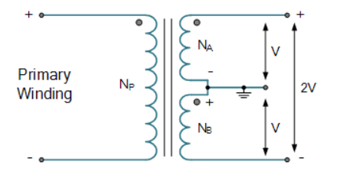

Figure shows a diagram of a three winding distribution transformer. The primary winding is given by $N_{P}$ and the secondary winding is $N_{s}=N_{A}+N_{B}$. Eq. shows the formula for an ideal transformer
$$\frac{N_{P}}{N_{s}}=\frac{V_{P}}{V_{S}}=\frac{I_{S}}{I_{P}}$$ | ()
Since the ratio of number of turns of the primary to the secondary is proportional to the ratio of the voltages, this means that the two voltages are $V_{A}=\frac{V_{s}}{2}$ and $V_{B}=\frac{V_{S}}{2}$. For this to be possible, the common ground must be connected in between both secondary windings.

Methodology
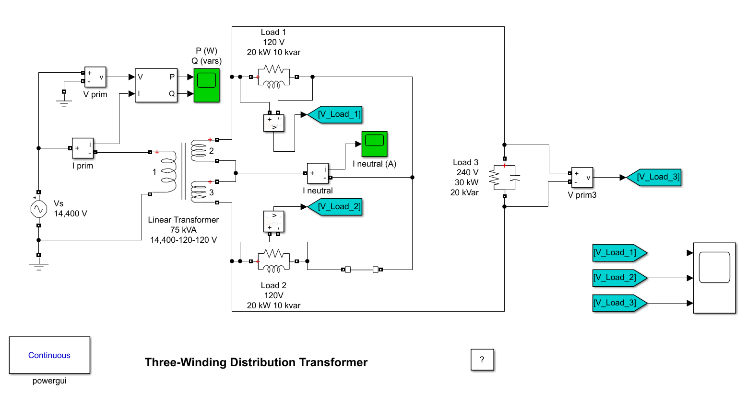
Figure shows the Simulink model built using a three-winding distribution transformer. This circuit is powered by a single phase and is made up of three resistive, inductive, and capacitive loads. The transformer primary is connected to a high voltage source (14,400 V rms). Two identical inductive loads (20 kW -10 kvar) are connected to the two secondaries. A third capacitive load (30 kW -20 kvar) is fed at 240 V. Windings 2 and 3 are connected in series with one another and the connection is used as the neutral wire. Initially, the circuit breaker in series with Load 2 is closed, so that the system is balanced. However, at 50ms, the circuit breaker connected to load 2 opens and the system is no longer balanced.
This circuit can represent many different applications such as a small factory, where there is a large input power, and it needs to be divided into different machines which each have different power consumptions. This is possibly a car factory where each stage of the assembly line requires different types of machines and has a certain power requirement.

Results & Analysis

Show the 3 voltages and current and p and q
Show calculations for each one (V,I,) balanced and unbalanced (after 50ms)
Talk about the center tap transformer

Dynamic load and programmable voltage source

Methodology

Results & Analysis

Part B – Load flow studies

Jacobi method

Gauss-Seidal method

Conclusions

References

Appendix

